Content Based Image Retrieval of MRI Scans of Brain on Hexagonal Sampled Grid

Rohit Raj
Department Of Computer Science and Engineering
B.V.B College of Engineering and Technology
Hubli, India
rohit314.raj@gmail.com

Suraj R. Prabhu
Department Of Computer Science and Engineering
B.V.B College of Engineering and Technology
Hubli, India
surajrp77@gmail.com

Gagan Purad
Department Of Computer Science and Engineering
B.V.B College of Engineering and Technology
Hubli, India
kcruzader@gmail.com

Under the guidance of Prof. Padmashree Desai,
Department of Computer Science and Engineering,
B.V.B College of Engineering and Technology, Hubli, India

ABSTRACT
Image processing is an expanding field with its applications spreading across several domains. There is extensive use of digital images for medical purposes which involves critical decisions to be made based on the elucidation of medical images such as MRI scan, CT scan, X-ray etc., and calls for substantial research. This paper is based on the project aimed at processing of MRI scans of brain. The proposed system performs content based retrieval of cases similar to the MRI scan loaded as query using Gabor wavelet based edge detection on hexagonal resampled grid.
General Terms
Retrieval, edge detection, resampling, feature extraction.
Keywords
CBIR, MRI, Gabor filter, GLCM, moment invariants, Euclidean distance, precision and recall.

INTRODUCTION
Content based image retrieval, CBIR, involves looking for similar images based on the content of the images rather than the metadata as in text based image retrieval. Features such as colour, shape and texture are extracted from the image and these serve as basis for further processing. Normal images are found to be in rectangular lattice, transforming them to hexagonal grid using re-sampling delivers improved feature parameters which in turn enhances the retrieval performance. Supporting factor being the resemblance of retina of human eye with the hexagonal grid space helps in replicating natural behavior in computer vision. Feature extraction starts with detection of edges which provides shape parameters. Gabor wavelet based edge detection technique is used in this work. Frequency and orientation representations of Gabor filters are similar to those of the human visual system, and they have been found to be particularly appropriate for texture representation and discrimination [1]. Gabor filter has the unique property of orientation selectivity that differentiates it from other edge detection techniques that can be represented as summation of different filters. In this work, Gabor filter is applied along three orientations 0⁰, 60⁰ and 120⁰ and the individual responses are superimposed to get the final edge map. This resulting edge map is used to obtain the shape features using moment invariants. Moments can provide characteristics of an object that uniquely represents its shape [2]. In this work Hu set of invariant moments [3] is used which comprises of seven simple properties such as moment of inertia, skew invariant etc., of an image. To extract the texture parameters Gray Level Co-occurrence Matrix (GLCM) method is used. Summarily, GLCM is a second order statistical texture features extraction technique followed in this work. Based on the generated GLCM matrix, texture features – energy, entropy, correlation and homogeneity are calculated.

CONTENT BASED IMAGE RETRIEVAL
As explained in the previous section CBIR can be considered as searching through a database of images not based on keywords but on image content. Image content refers to features such as colour, shape and texture. As all the MRI scans are in gray scale this project only uses shape and texture parameters for retrieval purpose. The methods applied for extracting these features have been explained in the following subsections.

Hexagonal Resampling
The process of feature extraction is preceded by resampling. It involves transforming images present in rectangular lattice to hexagonal grid space based on the half pixel shift method [4]. For each odd row, retain the pixel values of each odd column and discard the pixel values of each even column. Also for each even row, discard each odd column value and each even column value is set as the average of the left and right pixel values. The hexagonal sampling reduces mean sampling density in spatial domain [5] as compared to the rectangular sampling. In the steps described above, some pixel values have been discarded. However, the improved efficiency accounts for the loss of data

Gabor Wavelet Based Edge Detection
For feature representation and discrimination Gabor filters have been found to be predominantly suitable and also their frequency and orientation are similar to those of the human visual system. In the spatial domain, a 2D Gabor filter is a Gaussian kernel function modulated by a sinusoidal plane wave [1]. Integration of time/space and frequency data allows analysis of time frequency, which is termed as Gabor expansion. The filter has real and imaginary component representing orthogonal directions. The two components may be formed into a complex number or used individually. In this project only the real component of the filter has been used.

Where,
x’ = x cosθ + y sinθ
y’ = -xsinθ + y cosθ

In this equation, represents the wavelength of the sinusoidal factor, represents the orientation of the normal to the parallel stripes of a Gabor function, is the phase offset, is the sigma of the Gaussian envelope and is the spatial aspect ratio, and specifies the ellipticity of the support of the Gabor function

Moment Invariants
For 2D continuous function f(x,y) the moment of order (p + q) is defined as

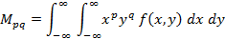
For p,q = 0, 1, 2 . . . Adapting this to scalar (greyscale) image with pixel intensities I(x,y), raw image M_{ij} are calculated by

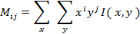

A uniqueness theorem (Hu [3]) states that if f(x,y) is piecewise continuous and has nonzero values only in a finite part of the xy plane, moments of all orders exist, and the moment sequence (M_{pq}) is uniquely determined by f(x,y). Conversely, (M_{pq}) uniquely determines f(x,y). In practice, the image is summarized with functions of a few lower order moments. Next, central moments are calculated using the following equations

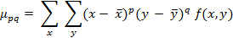

Where and are the components of the centroid. Using these central moments up to the desired order can be calculated. Moments η_{i j} where i + j ≥ 2 can be constructed to be invariant to both translation and changes in scale by dividing the corresponding central moment by the properly scaled (00)th moment, using the following formula

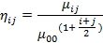

Hu set of moment invariants [3] for moments which are invariant under rotation, scaling and translation, are defined as

I1 = η₂₀ + η₀₂
I2 = (η₂₀ - η₀₂)² + 4
I3 = (η₃₀ - 3η₁₂)² + (3η₂₁ - η₀₃)²
I4 = (η₃₀ + η₁₂)² + (η₂₁ + η₀₃)²
I5 = (η₃₀ - 3η₁₂) (η₃₀ + η₁₂) [(η₃₀ + η₁₂)² –
3(η₂₁ - η₀₃)²] + (3η₂₁ - η₀₃)
(η₂₁ + η₀₃)[3(η₃₀ + η₁₂)² - (η₂₁ + η₀₃)²]

I6 = (η₂₀ - η₀₂) [(η₃₀ + η₁₂)² - (η₂₁ + η₀₃)²]
+ 4η₁₁(η₃₀ + η₁₂) (η₂₁ + η₀₃)
I7 = (3η₂₁ - η₀₃) (η₃₀ + η₁₂) [(η₃₀ + η₁₂)² –
3(η₂₁ + η₀₃)²] - (η₃₀ - 3η₁₂)

(η₂₁ + η₀₃)[3(η₃₀ + η₁₂)² - (η₂₁ + η₀₃)²]

GLCM Texture Measurements
Gray-Level Co-occurrence matrix is created from the image by calculating how often a pixel with gray-level (grayscale intensity) value i occurs horizontally adjacent to a pixel with value j [5] [6]. The outcome of GLCM for each element (i , j) is computed by summing the pixel with the value i occurred in the particular spatial relationship to a pixel with value j in the input series [7] [8] [9]. The co-occurrence probability between gray levels i and j, C_{ij} is defined as

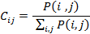

Where, P(i,j) represents number of occurrences of gray levels, i and j varies within the given image window for certain pairs of inter-pixel distance (δ) and orientation (θ). As explained by Haralick, after the computation of Gray-level Co-occurrence Matrix, the desired statistical texture measure can be found using co-occurrence probabilities. This probability measure can be defined as

The texture features can be calculated using the following equations

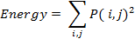

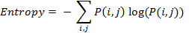

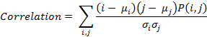

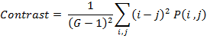

PROPOSED METHODOLOGY
The CBIR technique used for retrieval process is explained in this section. Initially the algorithm is run on the image database of MRI scans of brain, the shape and texture feature parameters are extracted and stored in a feature vector. The image transformed to hexagonal grid using the resampling process explained above is used for the feature extraction processes. When the query image is loaded, it undergoes the same process of resampling and then feature extraction, the results of which are stored in a separate feature vector (query feature vector). For retrieval process, extracted features of images in the database are compared with that of the features of the loaded query image. Comparison process involves calculation of Euclidean distances between the query feature vector and each record in the database feature vector. Least distance implies that the corresponding database image has high similarity with the query image. Based on these results, ten most similar images from the database are retrieved. The methods applied for shape and texture feature extraction has been covered in the below sub-sections

Shape Feature Extraction
Shape can be described by simple geometric features such as moment of inertia, skew invariants, center of gravity etc. The extraction of shape features starts with detection of edges. For this purpose Gabor filter is applied on six scale values – 0, 2, 4, 8, 16, 32 and three orientations – 0⁰, 60⁰, 120⁰, resulting in 6x3 = 18 edge-maps. Out of these only those satisfying the threshold value are superimposed to get the final edge-map. The next step is to get the shape features by applying moment invariants. The moment invariants are applied to the second-level wavelet decomposition results of the final edge-map. Since, second-level wavelet decomposition gives four coefficient matrices, namely approximation, horizontal, vertical and diagonal, results in total of 28 values (7 for each of the 4 components). These values are stored as shape features in the feature vector table.

Texture Feature Extraction
Important data regarding the structural arrangement of the surface is contained inside the texture features. Relationship between the surface and external environment can also be provided by them. For extraction of texture features, GLCM is used, which has been explained previously. In this study, first the co-occurrence matrix is created from which 13 texture parameters are calculated using the equations mentioned in previous section. The statistical texture measures used for this process include energy, entropy, correlation, contrast, sum of variances, inverse difference moment, information measure of correlation1, information measure of correlation2, sum average, sum entropy, sum variance, difference variance and difference entropy. These texture parameters are appended to the feature vector containing shape parameters. The combined feature vector is given in Table 1.

Table 1. Feature vector table
Image Id | Shape features  (7X4 = 28 values) | Texture features  (13 values)

The feature vector consists of 41 feature values (shape + texture) along with their corresponding image id.

Distance Calculation
The database feature vector for all the images in the database is created in accordance with the above mentioned process of feature extraction so is the feature vector for the query image. The Euclidean distance between the query and each of the database feature vectors is computed using the following equation.

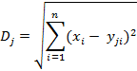

Where D_{j} = Euclidean distance for j^{th} image in the database, x_{i} = i^{th} feature value of the query image, y_{ji} = i^{th} feature value of the for j^{th} image in the database. Since there are 41 feature vector values n = 41. These distances are sorted in ascending order to retrieve the top 10 similar images.

RESULTS AND DISCUSSIONS
In this section the results obtained are shown and the performance evaluation in terms retrieval efficiency is discussed.

Experimental Setup and Results
The system is tested over 1500 MRI scans of brain images collected from local scan centres form the image database. MATLAB is used as the development platforms.

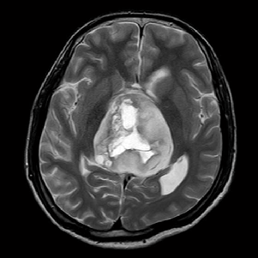

Fig. 1: Query image

The result of transforming a sample query (Fig. 1) image into hexagonal grid is shown in Fig. 2. Edge detection technique is applied on this resampled image. As previously mentioned Gabor filter will output 18 edge-maps. All these edge-maps are given in Fig. 3.
Out of these responses those satisfying the threshold value are superimposed to obtain the final edge map, given in Fig. 4.
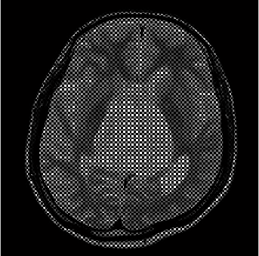
Fig. 2: Resampled Image
This edge map is subjected to second level decomposition and moment invariants are applied on them to extract the shape features, and store those features in a feature vector. For texture extraction, GLCM is created and statistical measures are calculated. These statistical measures are stored as texture features in the feature vector. The texture values are appended to the previously stored shape feature values in the same vector.
Retrieval results for a sample query images are shown in Fig. 5. The ten most similar images found after applying the methods discussed are displayed as the results.

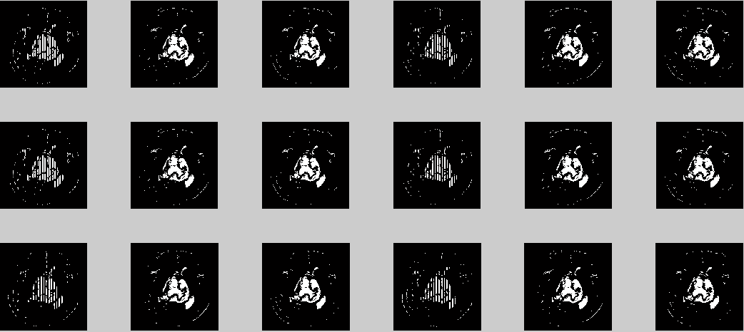

Fig. 3: Gabor filter response

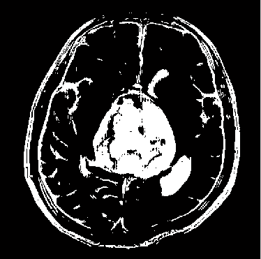
Fig. 4: Final edge-map

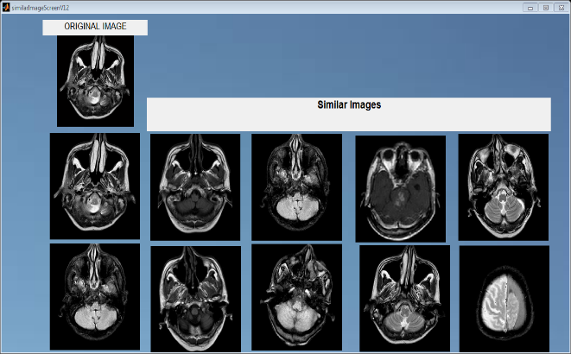
Fig. 5: Retrieval output for a sample query image

Retrieval Efficiency
For showing the efficiency of retrieval, precision and recall values were calculated for four randomly selected images from the 1500 images of brain MRI scan from MATLAB workspace database. Precision can be defined as the fraction of retrieved images that are relevant to the search. In a similar way recall can be defined as the fraction of images that are relevant to the query that are successfully retrieved. Formulas used for the calculation of precision and recall values are:

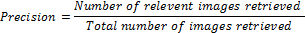

Table 2 shows the precision and recall values for the four query images randomly chosen. Precision varies from 70.0% to 90.0% and recall varies from 13.5% to 51.3%. From these precision and recall values it is possible to evaluate the retrieval efficiency by plotting thee graph of recall versus precision.
Table 2. Precision and Recall values in %
Image Id | Precision | Recall
14 | 80.0 | 47.4
24 | 70.0 | 13.5
37 | 90.0 | 24.8
92 | 80.0 | 51.3

According to the table values, graphical representation of recall versus precision is shown in Fig. 6. The recall values on horizontal axis are of image Id 14, 24, 37 and 92, respectively.

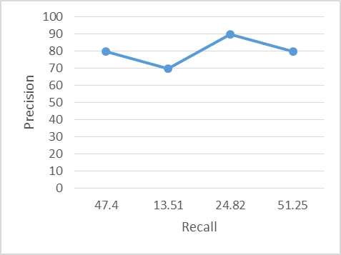
Fig. 6: Recall versus Precision graph

Discussions
Hexagonal resampling increases the peak signal to noise ratio, thereby, facilitating better extraction of shape and texture features. Euclidean distance used for distance calculation results in improved retrieval efficiency. For, measuring the performance of the proposed system, traditional parameters such as precision and recall measurements are used and the results are presented in Table 2 and corresponding graphical representation is also presented in Fig. 6. For precision the system gives, minimum 70.0% to a maximum 90.0% of the result and to recall it gives minimum13.5% to a maximum 51.3% of the result. It shows that the precision gives better performance in relevant image retrieval out of the retrieved images and recall gives its own performance in relevant image retrieval out of total images available in the database. Also the system provides a very good user interface for retrieving the images.

CONCLUSIONS
This study proposed a model for Content Based Image Retrieval by using shape and texture features of the images. Shape features are extracted from the hexagonal resampled image, which gives improved edge detection, by applying moment invariants on them. Using GLCM various statistical measures, representing the texture features, are computed. Final feature vector table contains both shape and texture features, resulting in improved retrieval. The measure of similarity between the query image and the database images is done by calculating the Euclidean distance. Smaller the distance, higher is the similarity. The system has been developed successfully in an efficient manner to achieve the expected output. The system is designed with flexible and consistent flow for easy understanding.

ACKNOWLEDGEMENTS
"The company of learned men is the key to the gates of wisdom". The satisfaction and euphoria that accompany the completion of any task would be incomplete without the mention of the people who made it possible, whose constant guidance and encouragement ground our efforts with success. We consider it a privilege to express our gratitude and respect to all those who guided us in completion of our project. We wholeheartedly thank Prof. Padmashree Desai, Associate Professor, Computer Science and Engineering, BVBCET-Hubli for her invaluable support and guidance. We also thank Project
co-ordinator, Prof. Vijayalaxm.M, Associate Professor, Computer Science and Engineering , BVBCET -Hubli ,whose guidance and knowledge was great use to us during this project work. We also like to thank Dr. Shah and Ms. Ujjwala at NMR Scan Centre for their co-operation and their extreme support.

REFERENCES
- http://en.wikipedia.org/wiki/Gabor_filter
- “Using Moment Invariants For Classifying Shapes On Large Scale Maps” Laura Keyes, Adam Winstanley; Department of Computer Science, National University of Ireland Maynooth, Co. Kildare, Ireland.
- “Visual Pattern Recognition by Moment Invariants”, M. K. Hu, IRE Trans. Info. Theory, vol. IT-8, pp.179-187, 1962
- “Hexagonal wavelet processing of digital, mammography”, A. Laine, S. Schuler, Medical Imaging 1993, Part of SPIE’s Thematic Applied Science and Engineering series, Newport Beach, California, February 14-19,1993.
- "Textural Features for Image Classification", Haralick, R.M., K. Shanmugan, and I. Dinstein, IEEE Transactions on Systems, Man, and Cybernetics, Vol. SMC-3, 1973, pp. 610-621.
- “Computer and Robot Vision: Vol. 1”, Haralick, R.M., and L.G. Shapiro., Addison-Wesley, 1992, p. 459
- “Content Based Medical Image Retrieval with Texture Content Using Gray Level Co-occurrence Matrix and K-Means Clustering Algorithms”, Ramamurthy, B. and K.R. Chandran; 1Department of CS, Sri Ramakrishna Engineering College, Coimbatore, India Department of CIS, PSG College of Technology, Coimbatore, India
- “Detection of abnormal texture in chest x-rays with reduction of ribs”, Park, M., J.S. Jin and L.S. Wilson, 2004. Proceedings of the Pan-Sydney Area Workshop on Visual Information Processing, (VIP’05), ACM, Australian Computer Society, Inc. Darlinghurst, Australia, pp: 71-74.
- “Rock texture retrieval using gray level co-occurrence matrix. Tampere University of Technology”, Partio, M., B. Cramariuc, M. Gabbouj and A. Visa, 2002.
- “Image information retrieval from incomplete queries using color and shape features”, Keshri Verma, Bikesh Kumar Singh, A. S. Thoke and Ankita Chan-drakar. Vol. 2(No. 4), December 2011.
- “Matlab as a tool in nuclear medicine image processing” Agapi Ploussi, Maria Lyra and Antonios Georgantzoglou, Radiation Physics Unit, A’ Radiology Department University of Athens, Greece, 2011.
- “Hexagonal parallel pattern transformation”, M.Golay, Vol. 18(No. 8):733-740, 1969.
- “Content based medical image retrieval with texture content using gray level co-occurrence matrix and k-means clustering algorithms”, B. Ramamurthy, Coimbatore India Department of CIS PSG College of Technology Coimbatore and K.R. Chandran Department of CS, Sri Ramakrishna Engineering College, 2012.
- “The process of hexagonally sampled two dimensional signals”, R.M.Mersereau, Vol. 67:930-949, 1979.
- “Image enhancement of medical images using gabor filter bank on hexagonal sampled grids”, K.A.Narayanankutty and Veni.S. 2003.
- “Gabor wavelets for image processing”, Jian Zhang, Yu Hu, Xin-Yi Wang, Wei Jiang, Ting-Zhi Shen, Department of Electronic Engineering School of Information Science and Technology, Beijing Institute of Technology, Beijing 100081 China. 2012.

